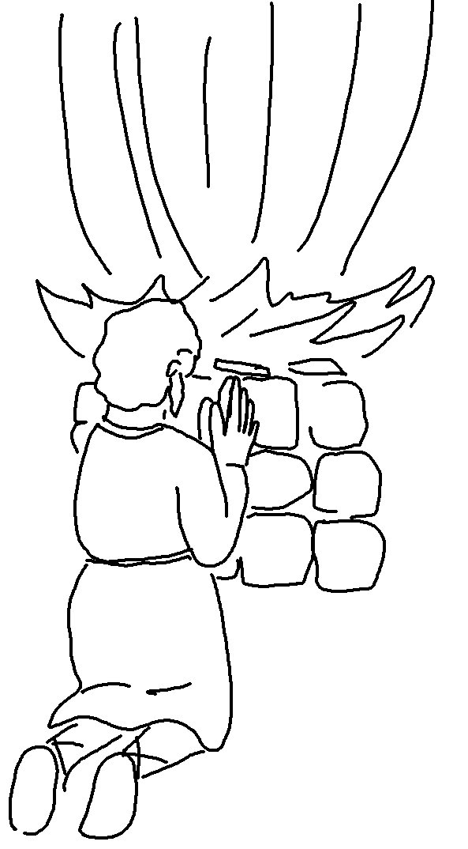
"The Lord—He is _ _ _!

Yes, the Lord is _ _ _!"
1 Kings 18:39_{NLT}

